- So as of now whenever we need to create test script in JMeter we just started recording but here if we want to create API test that means it doesn’t have any browser so we have to follow below process.
- Right click on Test Plan in JMeter -> Create a Thread Group
- Right click on Thread Group -> Add Sampler -> Select HTTP Request
- After that you can put test case name whatever you want.
- Here I am going to use Google API which Nearby Search API, below is the URL.
https://maps.googleapis.com/maps/api/place/nearbysearch/output?parameters

Lets split above URL so we can get clear idea
https://maps.googleapis.com/maps/api/place/nearbysearch/output?parameters - API
https://maps.googleapis.com/ -> Server Name or IP (Base URL)
maps/api/place/nearbysearch/ -> Path (Specified URL)
output -> We need to specify what type of output we need.
?parameters -> We need to specify our parameters
- In our URL after? mark we need to pass parameters and we can pass n number of parameters each Separated by & symbol.
- As per the above point, I have passed Base URL in place of Server Name or IP in Jmeter.
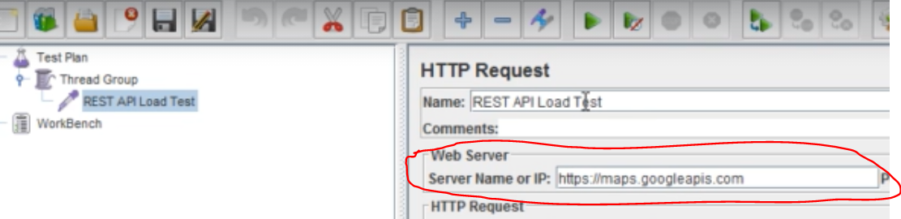
- Need to pass Relative path in place of path filed.
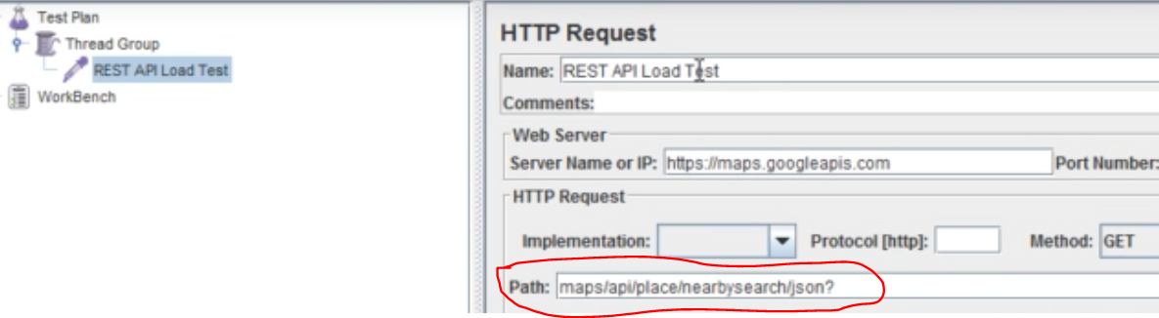
- In above screen shot I have mentioned json inplace of output that means i will get output in json format. If we need data in xml format then just replace xml inplace of json in above screen.
- Now We need to pass parameters, the above API is expecting few parameters like Key, location, radius, types, name etc.,
- Each parameter can be separated by $ symbol after each and every key value.
- We have to add these parameters under parameters section and pass respective values for those, like below screen shot.
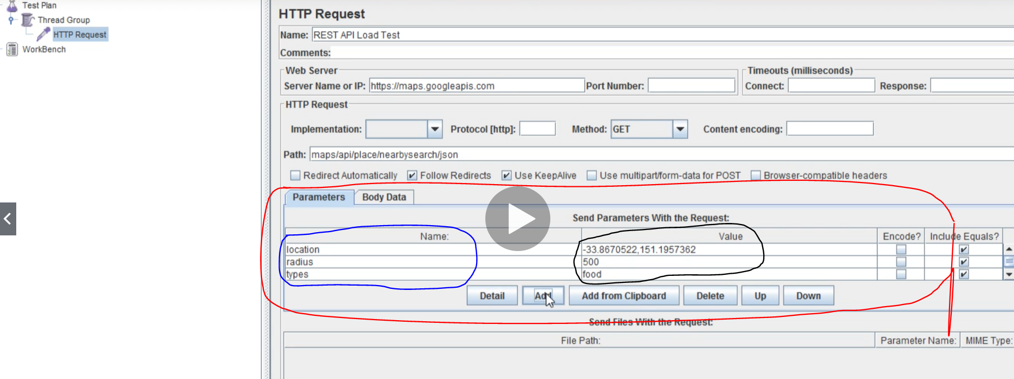
Blue pen – Keys (parameter names that API is expecting)
Black pen – Values (Values for the respective keys/parameters)
Red pen – Combination of Keys and Values (Parameters and Values)
- Unlike above point 12 we can pass parameters and respective values in another way too.
As per point number 8, will pass all these params and values in path itself. Like below
maps/api/place/nearbysearch/json?location=-33.8670522,151.1957362&radius=500&types=food&name=cruise&key=Addyourownkeyhere.

So that JMeter automatically parse your parameters even if you pass like above.
- Here we are applying GET request, so we need to select GET option from the method dropdown.
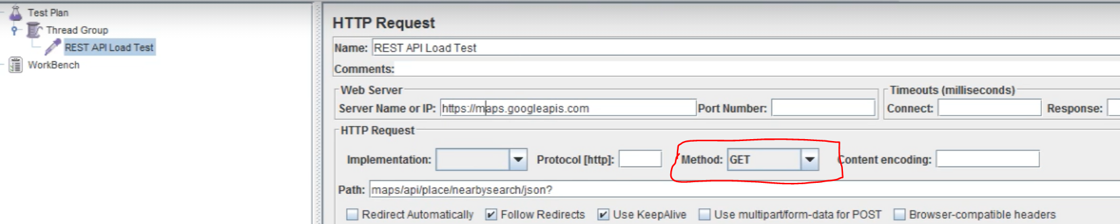

- Now you can click on Thread group and you can pass the thread count so that it will apply load on this particular server.
- Here we are accessing Google API, so we need API key that we need to create by following the attaching document.
- Now add Listeners and run the test script then you can see the response in json format.
- Below attached is Rest API test case Code dump file in JMeter.
Corrections in above screens:
- In point number 7, I have passed server name as
https://maps.googleapis.com/
but http is not required here hence pass below url as server name
maps.googlepais.com/
- In above point I have removed https so it will confuse how to search so add that https under protocol edit box.
https
